PURPOSE:  
Create table that contains item id and which char have that and which account is that where the account has login within l30day

(item_ownership.sql)

SQL CODE:

select

l.account_id,

l.userid,

l.lastlogin,

c.char_id,

i.id as ItemID

from

new_rathena_db.login AS l

left join

new_rathena_db.char AS c on c.account_id = l.account_id

left join

new_rathena_db.inventory AS i on i.char_id = c.char_id

WHERE

l.lastlogin >= NOW() - interval 30 day

AND

i.id > 0

ORDER BY

l.account_id,

l.userid,

c.char_id,

ItemID

ASC;

Table:

| account_id | userid | lastlogin | char_id | ItemID |
| --- | --- | --- | --- | --- |
| 2000001 | charismamamet | 2025-05-29 10:00:19 | 150006 | 40 |
| 2000001 | charismamamet | 2025-05-29 10:00:19 | 150006 | 41 |
| 2000001 | charismamamet | 2025-05-29 10:00:19 | 150006 | 42 |
| 2000001 | charismamamet | 2025-05-29 10:00:19 | 150006 | 43 |
| 2000001 | charismamamet | 2025-05-29 10:00:19 | 150006 | 44 |
| 2000001 | charismamamet | 2025-05-29 10:00:19 | 150006 | 46 |
| 2000001 | charismamamet | 2025-05-29 10:00:19 | 150006 | 51 |
| 2000001 | charismamamet | 2025-05-29 10:00:19 | 150006 | 77 |
| 2000001 | charismamamet | 2025-05-29 10:00:19 | 150006 | 221 |
| 2000001 | charismamamet | 2025-05-29 10:00:19 | 150006 | 239 |
| 2000001 | charismamamet | 2025-05-29 10:00:19 | 150006 | 250 |
| 2000001 | charismamamet | 2025-05-29 10:00:19 | 150006 | 251 |
| 2000001 | charismamamet | 2025-05-29 10:00:19 | 150006 | 470 |
| 2000001 | charismamamet | 2025-05-29 10:00:19 | 150006 | 595 |
| 2000001 | charismamamet | 2025-05-29 10:00:19 | 150006 | 850 |
| 2000001 | charismamamet | 2025-05-29 10:00:19 | 150006 | 883 |
| 2000001 | charismamamet | 2025-05-29 10:00:19 | 150006 | 884 |
| 2000001 | charismamamet | 2025-05-29 10:00:19 | 150006 | 899 |
| 2000001 | charismamamet | 2025-05-29 10:00:19 | 150006 | 927 |
| 2000001 | charismamamet | 2025-05-29 10:00:19 | 150006 | 928 |
| 2000001 | charismamamet | 2025-05-29 10:00:19 | 150006 | 929 |
| 2000001 | charismamamet | 2025-05-29 10:00:19 | 150006 | 930 |
| 2000001 | charismamamet | 2025-05-29 10:00:19 | 150006 | 931 |
| 2000001 | charismamamet | 2025-05-29 10:00:19 | 150006 | 941 |
| 2000001 | charismamamet | 2025-05-29 10:00:19 | 150006 | 942 |
| 2000001 | charismamamet | 2025-05-29 10:00:19 | 150006 | 943 |
| 2000001 | charismamamet | 2025-05-29 10:00:19 | 150006 | 944 |
| 2000001 | charismamamet | 2025-05-29 10:00:19 | 150006 | 958 |
| 2000001 | charismamamet | 2025-05-29 10:00:19 | 150006 | 961 |
| 2000001 | charismamamet | 2025-05-29 10:00:19 | 150006 | 969 |
| 2000001 | charismamamet | 2025-05-29 10:00:19 | 150006 | 977 |
| 2000001 | charismamamet | 2025-05-29 10:00:19 | 150006 | 978 |
| 2000001 | charismamamet | 2025-05-29 10:00:19 | 150006 | 982 |
| 2000001 | charismamamet | 2025-05-29 10:00:19 | 150006 | 983 |
| 2000001 | charismamamet | 2025-05-29 10:00:19 | 150006 | 986 |
| 2000001 | charismamamet | 2025-05-29 10:00:19 | 150006 | 998 |
| 2000001 | charismamamet | 2025-05-29 10:00:19 | 150006 | 1000 |
| 2000001 | charismamamet | 2025-05-29 10:00:19 | 150006 | 1015 |
| 2000001 | charismamamet | 2025-05-29 10:00:19 | 150006 | 1017 |
| 2000001 | charismamamet | 2025-05-29 10:00:19 | 150006 | 1018 |
| 2000001 | charismamamet | 2025-05-29 10:00:19 | 150006 | 1030 |
| 2000001 | charismamamet | 2025-05-29 10:00:19 | 150006 | 1034 |
| 2000001 | charismamamet | 2025-05-29 10:00:19 | 150006 | 1037 |
| 2000001 | charismamamet | 2025-05-29 10:00:19 | 150006 | 1038 |
| 2000001 | charismamamet | 2025-05-29 10:00:19 | 150006 | 1039 |
| 2000001 | charismamamet | 2025-05-29 10:00:19 | 150006 | 1040 |
| 2000001 | charismamamet | 2025-05-29 10:00:19 | 150006 | 1041 |
| 2000001 | charismamamet | 2025-05-29 10:00:19 | 150006 | 1042 |
| 2000001 | charismamamet | 2025-05-29 10:00:19 | 150006 | 1043 |
| 2000001 | charismamamet | 2025-05-29 10:00:19 | 150006 | 1044 |
| 2000001 | charismamamet | 2025-05-29 10:00:19 | 150006 | 1045 |
| 2000001 | charismamamet | 2025-05-29 10:00:19 | 150006 | 1046 |
| 2000001 | charismamamet | 2025-05-29 10:00:19 | 150006 | 1047 |
| 2000001 | charismamamet | 2025-05-29 10:00:19 | 150006 | 1048 |
| 2000001 | charismamamet | 2025-05-29 10:00:19 | 150006 | 1049 |
| 2000001 | charismamamet | 2025-05-29 10:00:19 | 150008 | 270 |
| 2000001 | charismamamet | 2025-05-29 10:00:19 | 150008 | 277 |
| 2000001 | charismamamet | 2025-05-29 10:00:19 | 150008 | 313 |
| 2000001 | charismamamet | 2025-05-29 10:00:19 | 150008 | 318 |
| 2000001 | charismamamet | 2025-05-29 10:00:19 | 150008 | 323 |
| 2000001 | charismamamet | 2025-05-29 10:00:19 | 150008 | 337 |
| 2000001 | charismamamet | 2025-05-29 10:00:19 | 150008 | 411 |
| 2000001 | charismamamet | 2025-05-29 10:00:19 | 150008 | 532 |
| 2000001 | charismamamet | 2025-05-29 10:00:19 | 150008 | 577 |
| 2000001 | charismamamet | 2025-05-29 10:00:19 | 150008 | 702 |
| 2000001 | charismamamet | 2025-05-29 10:00:19 | 150008 | 705 |
| 2000001 | charismamamet | 2025-05-29 10:00:19 | 150008 | 706 |
| 2000001 | charismamamet | 2025-05-29 10:00:19 | 150008 | 707 |
| 2000001 | charismamamet | 2025-05-29 10:00:19 | 150008 | 708 |
| 2000001 | charismamamet | 2025-05-29 10:00:19 | 150008 | 709 |
| 2000001 | charismamamet | 2025-05-29 10:00:19 | 150008 | 713 |
| 2000001 | charismamamet | 2025-05-29 10:00:19 | 150008 | 714 |
| 2000001 | charismamamet | 2025-05-29 10:00:19 | 150008 | 715 |
| 2000001 | charismamamet | 2025-05-29 10:00:19 | 150008 | 716 |
| 2000001 | charismamamet | 2025-05-29 10:00:19 | 150008 | 717 |
| 2000001 | charismamamet | 2025-05-29 10:00:19 | 150008 | 718 |
| 2000001 | charismamamet | 2025-05-29 10:00:19 | 150008 | 719 |
| 2000001 | charismamamet | 2025-05-29 10:00:19 | 150008 | 720 |
| 2000001 | charismamamet | 2025-05-29 10:00:19 | 150008 | 721 |
| 2000001 | charismamamet | 2025-05-29 10:00:19 | 150008 | 722 |
| 2000001 | charismamamet | 2025-05-29 10:00:19 | 150008 | 734 |
| 2000001 | charismamamet | 2025-05-29 10:00:19 | 150008 | 735 |
| 2000001 | charismamamet | 2025-05-29 10:00:19 | 150008 | 736 |
| 2000001 | charismamamet | 2025-05-29 10:00:19 | 150008 | 737 |
| 2000001 | charismamamet | 2025-05-29 10:00:19 | 150008 | 738 |
| 2000001 | charismamamet | 2025-05-29 10:00:19 | 150008 | 739 |
| 2000001 | charismamamet | 2025-05-29 10:00:19 | 150008 | 740 |
| 2000001 | charismamamet | 2025-05-29 10:00:19 | 150008 | 741 |
| 2000001 | charismamamet | 2025-05-29 10:00:19 | 150008 | 748 |
| 2000001 | charismamamet | 2025-05-29 10:00:19 | 150008 | 749 |
| 2000001 | charismamamet | 2025-05-29 10:00:19 | 150008 | 750 |
| 2000001 | charismamamet | 2025-05-29 10:00:19 | 150008 | 751 |
| 2000001 | charismamamet | 2025-05-29 10:00:19 | 150008 | 752 |
| 2000001 | charismamamet | 2025-05-29 10:00:19 | 150008 | 759 |
| 2000001 | charismamamet | 2025-05-29 10:00:19 | 150008 | 761 |
| 2000001 | charismamamet | 2025-05-29 10:00:19 | 150008 | 769 |
| 2000001 | charismamamet | 2025-05-29 10:00:19 | 150008 | 803 |
| 2000001 | charismamamet | 2025-05-29 10:00:19 | 150008 | 804 |
| 2000001 | charismamamet | 2025-05-29 10:00:19 | 150008 | 805 |
| 2000001 | charismamamet | 2025-05-29 10:00:19 | 150008 | 806 |
| 2000001 | charismamamet | 2025-05-29 10:00:19 | 150008 | 807 |
| 2000001 | charismamamet | 2025-05-29 10:00:19 | 150008 | 808 |
| 2000001 | charismamamet | 2025-05-29 10:00:19 | 150008 | 809 |
| 2000001 | charismamamet | 2025-05-29 10:00:19 | 150008 | 810 |
| 2000001 | charismamamet | 2025-05-29 10:00:19 | 150008 | 811 |
| 2000001 | charismamamet | 2025-05-29 10:00:19 | 150008 | 812 |
| 2000001 | charismamamet | 2025-05-29 10:00:19 | 150008 | 813 |
| 2000001 | charismamamet | 2025-05-29 10:00:19 | 150008 | 814 |
| 2000001 | charismamamet | 2025-05-29 10:00:19 | 150008 | 815 |
| 2000001 | charismamamet | 2025-05-29 10:00:19 | 150008 | 816 |
| 2000001 | charismamamet | 2025-05-29 10:00:19 | 150008 | 818 |
| 2000001 | charismamamet | 2025-05-29 10:00:19 | 150008 | 819 |
| 2000001 | charismamamet | 2025-05-29 10:00:19 | 150008 | 820 |
| 2000001 | charismamamet | 2025-05-29 10:00:19 | 150008 | 821 |
| 2000001 | charismamamet | 2025-05-29 10:00:19 | 150009 | 518 |
| 2000001 | charismamamet | 2025-05-29 10:00:19 | 150009 | 519 |
| 2000001 | charismamamet | 2025-05-29 10:00:19 | 150009 | 520 |
| 2000001 | charismamamet | 2025-05-29 10:00:19 | 150009 | 521 |
| 2000002 | tanteratna | 2025-05-18 14:54:24 | 150007 | 273 |
| 2000002 | tanteratna | 2025-05-18 14:54:24 | 150007 | 299 |
| 2000002 | tanteratna | 2025-05-18 14:54:24 | 150007 | 306 |
| 2000002 | tanteratna | 2025-05-18 14:54:24 | 150007 | 307 |
| 2000002 | tanteratna | 2025-05-18 14:54:24 | 150007 | 308 |
| 2000002 | tanteratna | 2025-05-18 14:54:24 | 150007 | 309 |
| 2000002 | tanteratna | 2025-05-18 14:54:24 | 150007 | 314 |
| 2000002 | tanteratna | 2025-05-18 14:54:24 | 150007 | 322 |
| 2000002 | tanteratna | 2025-05-18 14:54:24 | 150007 | 335 |
| 2000002 | tanteratna | 2025-05-18 14:54:24 | 150007 | 339 |
| 2000002 | tanteratna | 2025-05-18 14:54:24 | 150007 | 531 |
| 2000002 | tanteratna | 2025-05-18 14:54:24 | 150007 | 587 |
| 2000002 | tanteratna | 2025-05-18 14:54:24 | 150007 | 660 |
| 2000002 | tanteratna | 2025-05-18 14:54:24 | 150007 | 667 |
| 2000002 | tanteratna | 2025-05-18 14:54:24 | 150007 | 712 |
| 2000002 | tanteratna | 2025-05-18 14:54:24 | 150007 | 723 |
| 2000002 | tanteratna | 2025-05-18 14:54:24 | 150007 | 724 |
| 2000002 | tanteratna | 2025-05-18 14:54:24 | 150007 | 725 |
| 2000002 | tanteratna | 2025-05-18 14:54:24 | 150007 | 726 |
| 2000002 | tanteratna | 2025-05-18 14:54:24 | 150007 | 727 |
| 2000002 | tanteratna | 2025-05-18 14:54:24 | 150007 | 728 |
| 2000002 | tanteratna | 2025-05-18 14:54:24 | 150007 | 729 |
| 2000002 | tanteratna | 2025-05-18 14:54:24 | 150007 | 730 |
| 2000002 | tanteratna | 2025-05-18 14:54:24 | 150007 | 731 |
| 2000002 | tanteratna | 2025-05-18 14:54:24 | 150007 | 732 |
| 2000002 | tanteratna | 2025-05-18 14:54:24 | 150007 | 733 |
| 2000002 | tanteratna | 2025-05-18 14:54:24 | 150007 | 742 |
| 2000002 | tanteratna | 2025-05-18 14:54:24 | 150007 | 743 |
| 2000002 | tanteratna | 2025-05-18 14:54:24 | 150007 | 744 |
| 2000002 | tanteratna | 2025-05-18 14:54:24 | 150007 | 745 |
| 2000002 | tanteratna | 2025-05-18 14:54:24 | 150007 | 746 |
| 2000002 | tanteratna | 2025-05-18 14:54:24 | 150007 | 747 |
| 2000002 | tanteratna | 2025-05-18 14:54:24 | 150007 | 754 |
| 2000002 | tanteratna | 2025-05-18 14:54:24 | 150007 | 755 |
| 2000002 | tanteratna | 2025-05-18 14:54:24 | 150007 | 757 |
| 2000002 | tanteratna | 2025-05-18 14:54:24 | 150007 | 758 |
| 2000002 | tanteratna | 2025-05-18 14:54:24 | 150007 | 763 |
| 2000002 | tanteratna | 2025-05-18 14:54:24 | 150007 | 764 |
| 2000002 | tanteratna | 2025-05-18 14:54:24 | 150007 | 765 |
| 2000002 | tanteratna | 2025-05-18 14:54:24 | 150007 | 766 |
| 2000002 | tanteratna | 2025-05-18 14:54:24 | 150007 | 770 |
| 2000002 | tanteratna | 2025-05-18 14:54:24 | 150007 | 771 |
| 2000002 | tanteratna | 2025-05-18 14:54:24 | 150007 | 772 |

PURPOSE:

Table containing users with most zeny only

(zeny_owner.sql)

SQL Code:

select

c.char_id,

c.account_id,

c.name,

l.userid,

c.zeny

FROM

new_rathena_db.char as c

JOIN

new_rathena_db.login as l

ON

l.account_id = c.account_id

order BY

c.zeny DESC

;

**Table:**

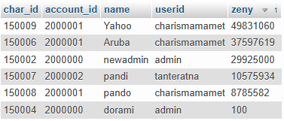

PURPOSE:  
 Table containing users with most zeny and unique item

(zeny_and_item_owner.sql)

SQL CODE:

Select

c.char_id,

c.account_id,

c.name,

c.zeny,

count(distinct i.nameid) as numofitem

from new_rathena_db.char as c

left join new_rathena_db.inventory as i on i.char_id = c.char_id

group by /* this should exist so we can get all of the char id row. Without it, we will get only one row that is the effect of count(distinct) formula */

c.char_id,

c.account_id,

c.name,

c.zeny

order by c.zeny desc;

**Table:**

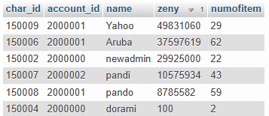

PURPOSE:  
Number of daily active users last 30 days

(dau_l30d_nominal.sql)

SQL CODE:

SELECT

date(ll.time) as login_date /* need to use date(ll.time) since ll.time is formatted as datetime while i only care about the date*/,

count(distinct ll.user) as numofloginuser

FROM

new_rathena_db.loginlog as ll

where

log = 'login ok' /*in rAthena, char server and map server login also got count as login and it got put within the same loginlog. Meanwhile, i only care about user log in which is marked as ‘login ok’*/

group by

login_date

order by

login_date DESC

limit 30;

Table:

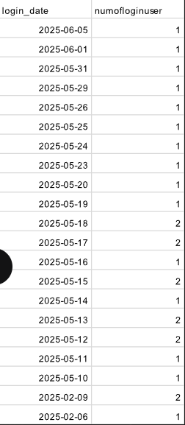

PURPOSE 2:  
The user id of daily active users last 30 days

(dau_l30d_user.sql)

SQL CODE:

select

date(ll.time) as login_date,

ll.user,

count(user) as numOfLogin

from

new_rathena_db.loginlog as ll

where

ll.log = 'login ok'

AND

not ll.user = 's1'

AND

not ll.user like '%admin%'

group by

ll.user,

login_date

order by

login_date desc

;

**Table:**

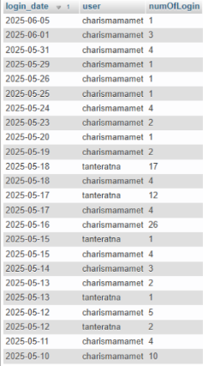

**PURPOSE:**Accounts that haven’t logged in for over 90 days or haven't log in at all

(stale_sign_up.sql)

**SQL CODE:**

select l.userid, l.sex, l.group_id, l.email, l.lastlogin, l.logincount

from new_rathena_db.login as l

where

l.lastlogin <= now() - interval 90 day

OR

l.lastlogin is null

group by

l.userid

order by l.group_id desc

;

**Table**:

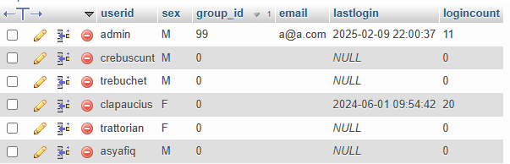

**PURPOSE 1:**Find Account that has no char or less than 2 char

(lost_or_about_to_lose.sql)

SQL CODE:

select

l.account_id,

l.userid,

count(distinct c.char_id) as numofchar

From

new_rathena_db.login as l

left join

new_rathena_db.char as c on c.account_id = l.account_id

group by

l.account_id,

l.userid

having

numofchar <= 1

order BY

numofchar DESC

;

**Table**

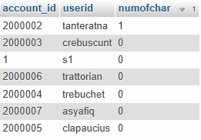

**PURPOSE 2:**

Find account that has at least 2 char

(actual_player.sql)

**SQL CODE:**

select

l.account_id,

l.userid,

count(distinct c.char_id) as numofchar

From

new_rathena_db.login as l

left join

new_rathena_db.char as c on c.account_id = l.account_id

where

c.char_id IS NOT NULL

And not l.userid = 'admin'

group by

l.account_id,

l.userid

having

numofchar >= 2

order by

numofchar DESC

;

**Table**



**PURPOSE 3:**

When user has more than 1 char, mark it as char collector. If they have non zero but max 1 char, mark it as casual player

(playerStatus.sql)

Sql:

select

l.account_id,

l.userid,

count(distinct c.char_id) as numofchar,

case

when count(distinct c.char_id) > 1 then 'char collector'

when count(distinct c.char_id) = 0 then 'no char'

else 'casual player'

end as playerStatus

From

new_rathena_db.login as l

left join

new_rathena_db.char as c on c.account_id = l.account_id

group by

l.account_id,

l.userid

order BY

numofchar DESC

;

**Table:**

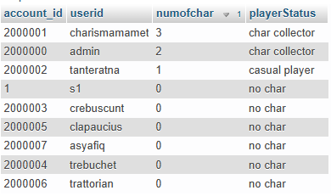

**PURPOSE**:

Find list of account that has more than average char inside it

(char_more_than_avg.sql)

**SQL**:

WITH

kepemilikanChar as (

select

c.account_id,

l.userid,

count(c.char_id) as numOfChar

FROM

new_rathena_db.char as c

JOIN

new_rathena_db.login as l

ON

l.account_id = c.account_id

group BY

c.account_id,

l.userid

order BY

c.zeny DESC

),

avgOwnedChar as (

SELECT

avg(numOfChar) as averageCharInAllAccount

FROM

kepemilikanChar

)

select

kpc.account_id,

kpc.userid,

kpc.numOfChar,

aoc.averageCharInAllAccount

FROM

kepemilikanChar as kpc

CROSS JOIN

avgOwnedChar as aoc

WHERE

kpc.numOfChar >= aoc.averageCharInAllAccount

group BY

kpc.account_id,

kpc.userid

order BY

kpc.numOfChar DESC

**TABLE**:

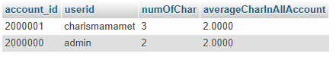

**PURPOSE:**How many item each char own

(totalOwnedItem.sql)

SQL CODE:

WITH item_stats as (

select

c.char_id,

c.name,

c.account_id,

count(distinct i.nameid) as distinctOwnedItem,

sum(i.amount) as totalOwnedItem

from new_rathena_db.char as c

left join new_rathena_db.inventory as i on i.char_id = c.char_id

group by c.char_id

),

avg_stats as (

SELECT

AVG(distinctOwnedItem) as avgItem

from item_stats

),

avg_stats2 as (

SELECT

avg(totalOwnedItem) as avgItem2

from item_stats

)

select

alif.char_id,

alif.name,

alif.account_id,

alif.distinctOwnedItem,

alif.totalOwnedItem,

CASE

when alif.distinctOwnedItem > ba.avgItem then 'item collector'

else 'casual player'

end as playerItemStatus1,

CASE

when alif.totalOwnedItem > ta.avgItem2 then 'item hoarder'

else 'casual player'

end as playerItemStatus2

from item_stats as alif

cross join avg_stats as ba

cross join avg_stats2 as ta

order by distinctOwnedItem DESC

;

**Table**

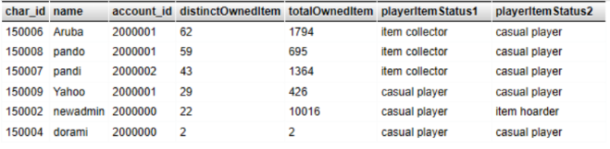

**PURPOSE:**Top 3 common items

(commonItem.sql)

SQL:

select

i.nameid,

count(distinct i.char_id) as numOfDistinctOwner

from new_rathena_db.inventory as i

group by

i.nameid

order by numOfDistinctOwner desc

limit 3

;

**Table**

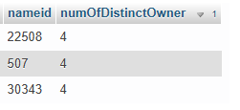

**PURPOSE:**Find all users with user_id starting/ending with a certain letter or number. In this case, the userid start with letter c

(user_start_c.sql)

SQL CODE:

select l.userid, l.sex, l.group_id, l.email

from new_rathena_db.login as l

where l.userid like "c%"

order by l.group_id desc

;

Table:

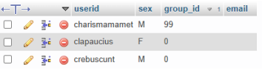

**PURPOSE:**Accounts that got flagged with cheat potential. In this case, it is marked by those who get item id 6124, a wolf flute, which is a god item that can summon wolf god.

(cheatSus.sql)

**SQL CODE:**

select

l.account_id,

l.userid,

c.char_id

from

new_rathena_db.login as l

left join

new_rathena_db.char as c

on c.account_id = l.account_id

left join

new_rathena_db.inventory as i

on i.char_id = c.char_id

where

i.nameid = 6124

;

**Table**

